CrossAngle (Xangle) Announces Strategic Partnership with Blockchain Security Company CertiK
- Xangle and CertiK partner to share data, industry analysis reports, and more.
- They aim to foster the growth of the Web3 ecosystem by leveraging the synergy of on-chain data analytics and blockchain security solutions.
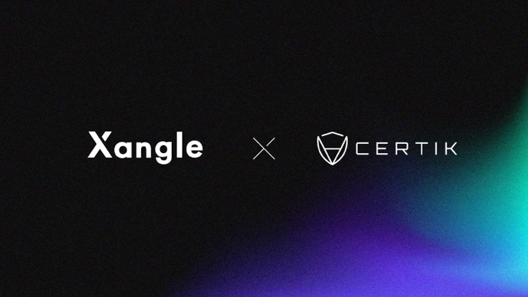

Seoul, September 20, 2023 – CertiK, a leading blockchain security solution provider, and Xangle, a crypto data intelligence platform, announced a strategic partnership aimed at promoting Web3 mass adoption.

CrossAngle, the crypto data intelligence provider behind the Xangle platform today announced its partnership with Certik, a leader in blockchain security.

Under this landmark partnership, Xangle gains access to CertiK's API data, including Skynet security data while CertiK receives real-time crypto market prices and data-driven on-chain analytics from Xangle. Furthermore, Certik's industry analysis reports will become a regular feature on Xangle's research platform. Xangle's research reports are highly regarded for their expertise and have a regular presence on both domestic and international financial information platforms such as Bloomberg Terminal, CoinMarketCap, Yonhap Infomax, and F&Guide.

Skynet is a comprehensive security and due diligence insights platform for the Web3 ecosystem developed by CertiK. It provides active, round-the-clock on-chain monitoring of security threats. By combining Xangle's strength in on-chain data analytics and research with blockchain security expert CertiK's specialized data, the two companies are set to contribute to the creation of a transparent blockchain ecosystem.

Jake Lim, Chief Business Development Officer of Xangle, expressed enthusiasm about the partnership, stating, "We are thrilled to partner with world-class Web3 security company CertiK. We are excited about the synergies with Xangle's prowess in on-chain data analytics and believe that our collaboration will help accelerate the ongoing mass adoption of Web3."

Jason Jiang, Chief Business Officer of CertiK, echoed this excitement, saying, "We are excited to partner with Xangle, renowned for its precise and high-quality Web3 data analytics. Together, we aspire not only to bolster security and transparency in the blockchain ecosystem but also to set new standards for the industry."

